Fork Lift Demo

Have the installation complete!

1. Start Electron – open a bash command window in the directory and type: npm start

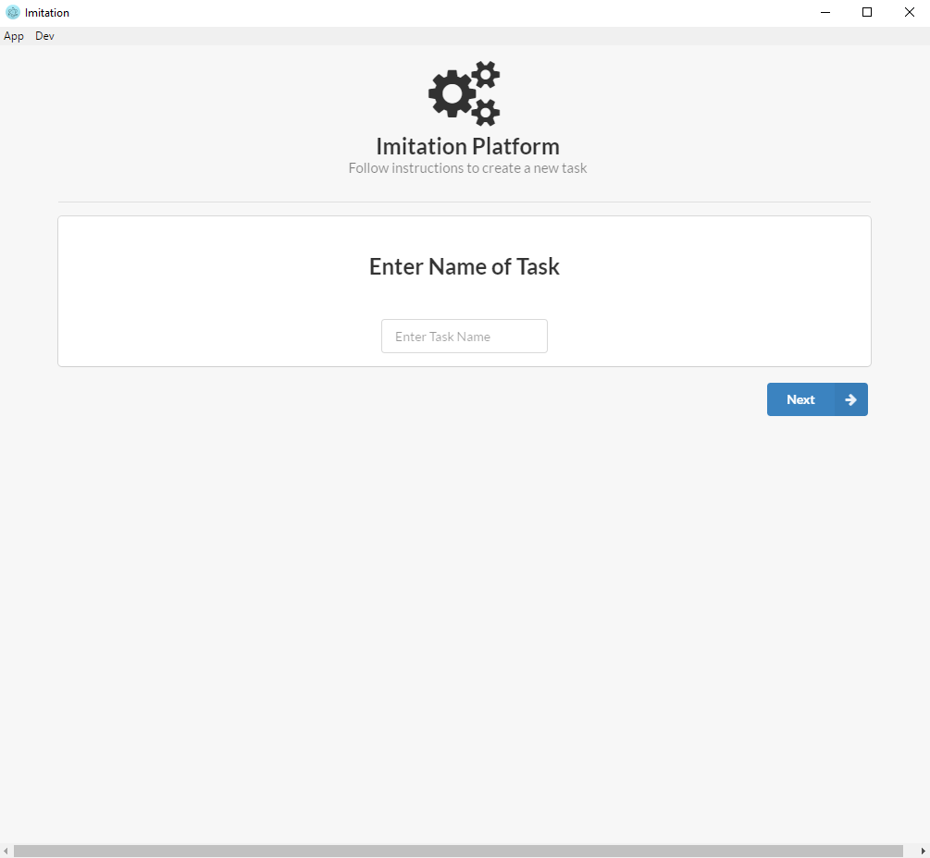

1. Enter fork lift as the Task Name and press Next
2. The Generate XML page is for creating XML layouts. For the Fork Lift demo this was not used. So skip this page by clicking Next

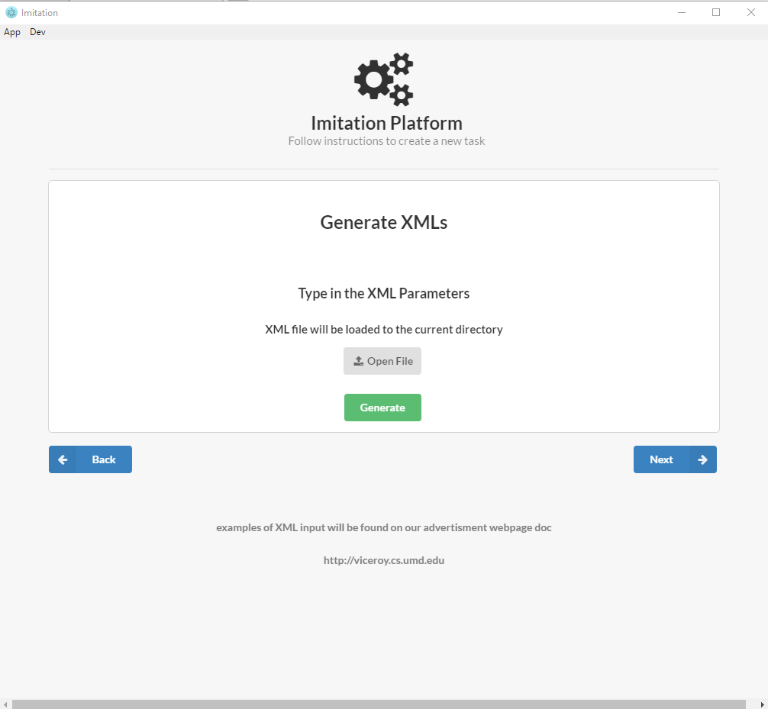

1. On SMILE Recordings page. Click on Open File and select the following files:
   1. 1 – 10.txt located in:

electron\Imitation \Forklift\SMILE Recordings\forklift and block stacking

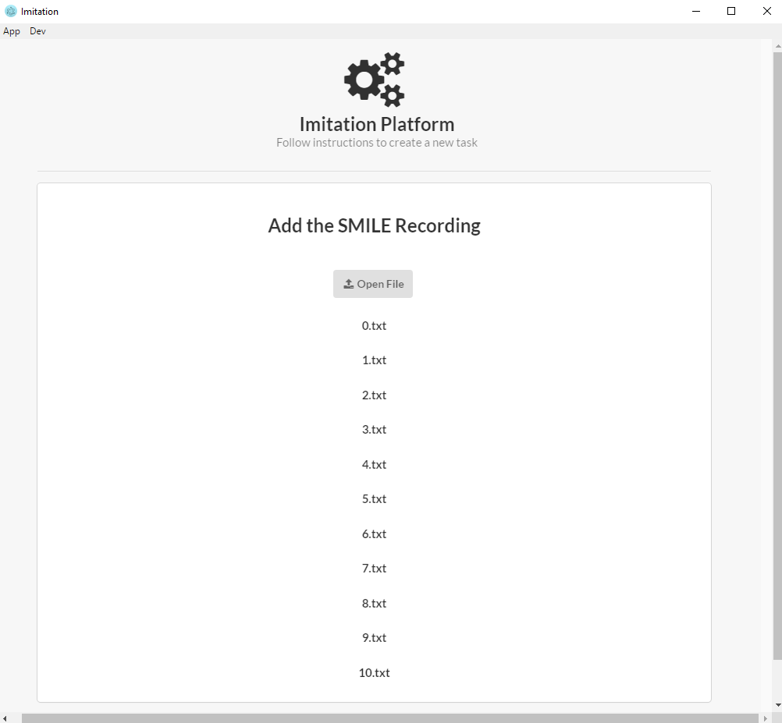

1. On the Build Knowledge Base page, we allow 2 options. Go to Builder takes you through the steps to create a knowledge base. At the end of this, a text file will be generated with the format we designed. Below will be steps to use this builder. Or, click on Open File and select __. This file is the generated file if a user went through the builder. If chosen to skip the builder, open the file, the next button will appear, click Next and skip to step 8.

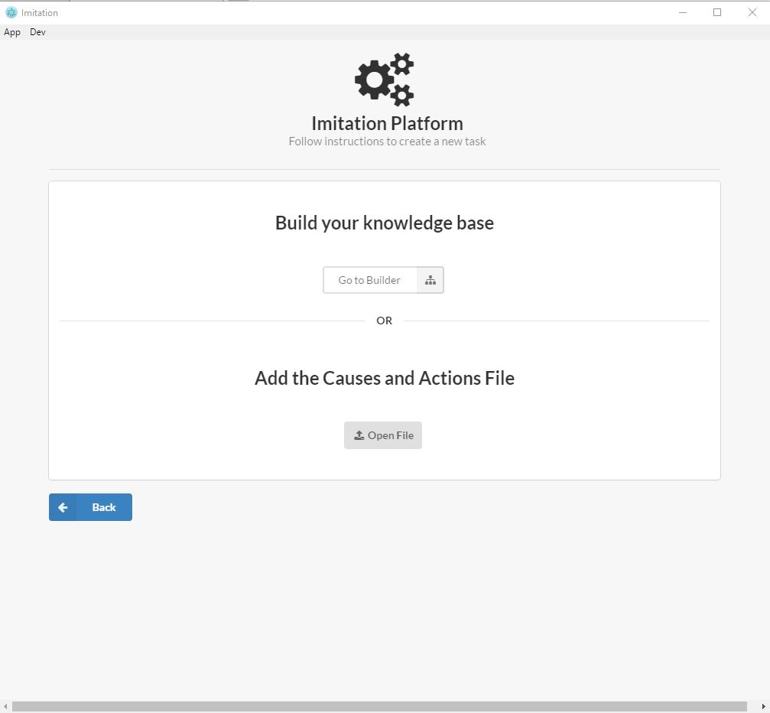

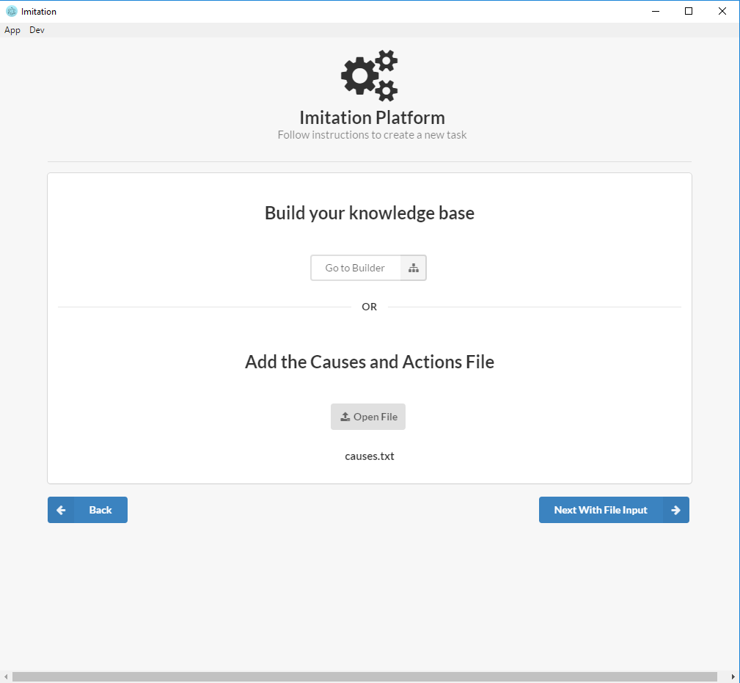

1. Instructions for the Knowledge Base Builder.
   1. Define Causes and Actions
      1. Causes – Type for each cause input
         * move-to
           1. Actions for move-to – Type for each action input

grasp

release

* + - * stack
        1. Actions for stack – Type for each action input

move-to

* + - * stack (yes there will be 2 stacks)
        1. Actions for stack – Type for each action input

move-to

stack

* + - * stack-all
        1. Actions for stack-all – Type for each action input

Stack

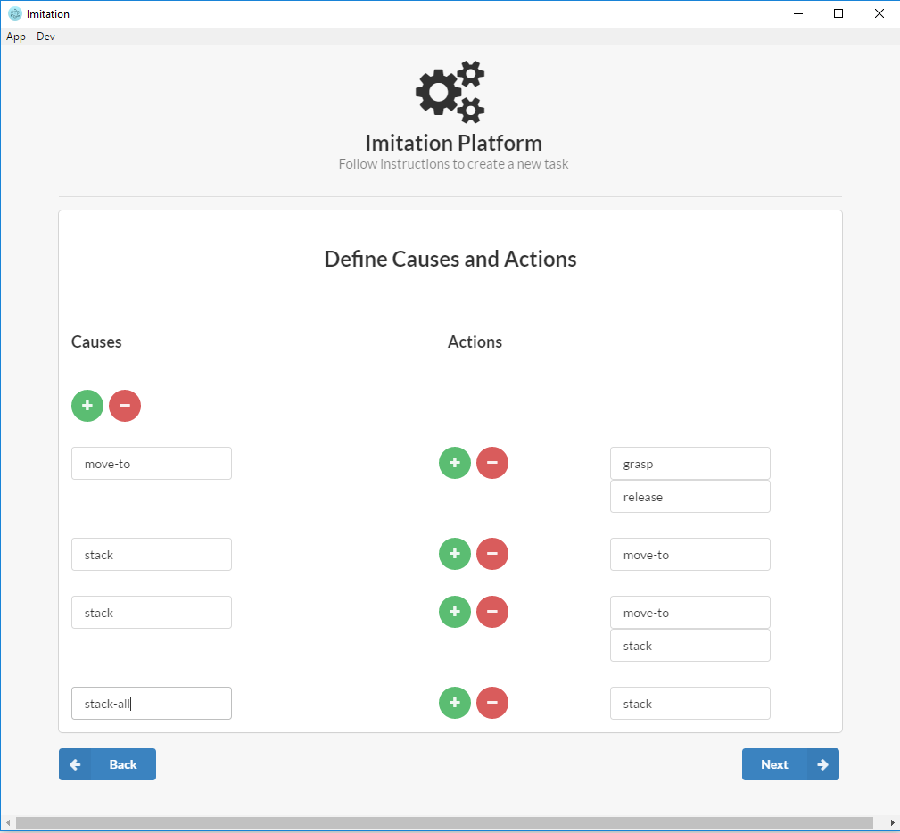

* 1. Define Causal Relations
     1. Move-to set to Direct
     2. Stack set to Conditional
        + TYPE(obj)=block
     3. Stack set to Conditional
        + TYPE(obj1) = block && obj = obj1
     4. Stack-all set to Conditional
        + ALL(block)=[obj1, CONT1] && dest = 'room'

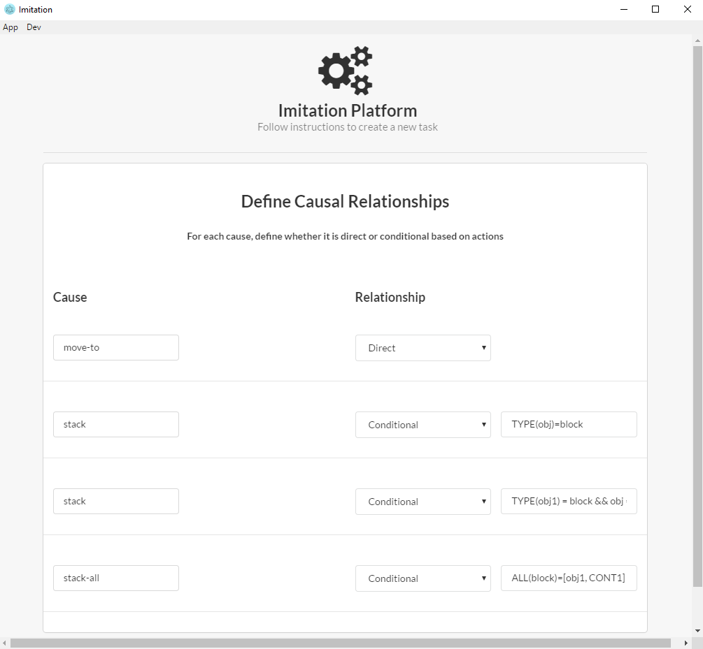

* 1. Define Actions Parameters
     1. Move-to actions
        + Grasp
          1. Obj
        + Release
          1. Obj
          2. Dest
          3. Dx
          4. Dy
          5. Dz
          6. Da
     2. Stack actions
        + Move-to
          1. Obj
          2. Dest
          3. Dx
          4. Dy
          5. Dz
          6. Da
     3. Stack actions
        + Move-to
          1. Dest
          2. Dx
          3. Dy
          4. Dz
          5. Da
          6. obj
        + Stack
          1. Obj1
          2. 0
          3. 0
          4. 0.5
          5. 0
          6. Obj2
          7. Obj3
          8. CONT2
     4. Stack-all actions
        + Stack
          1. Dest
          2. Dx
          3. Dy
          4. Dz
          5. Da
          6. Obj1
          7. Cont1

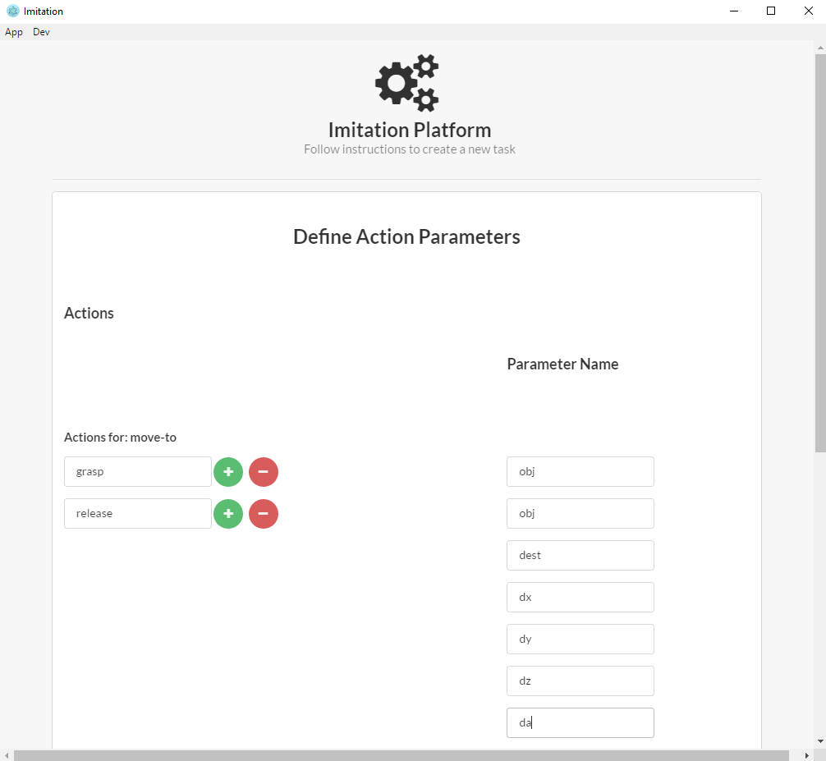

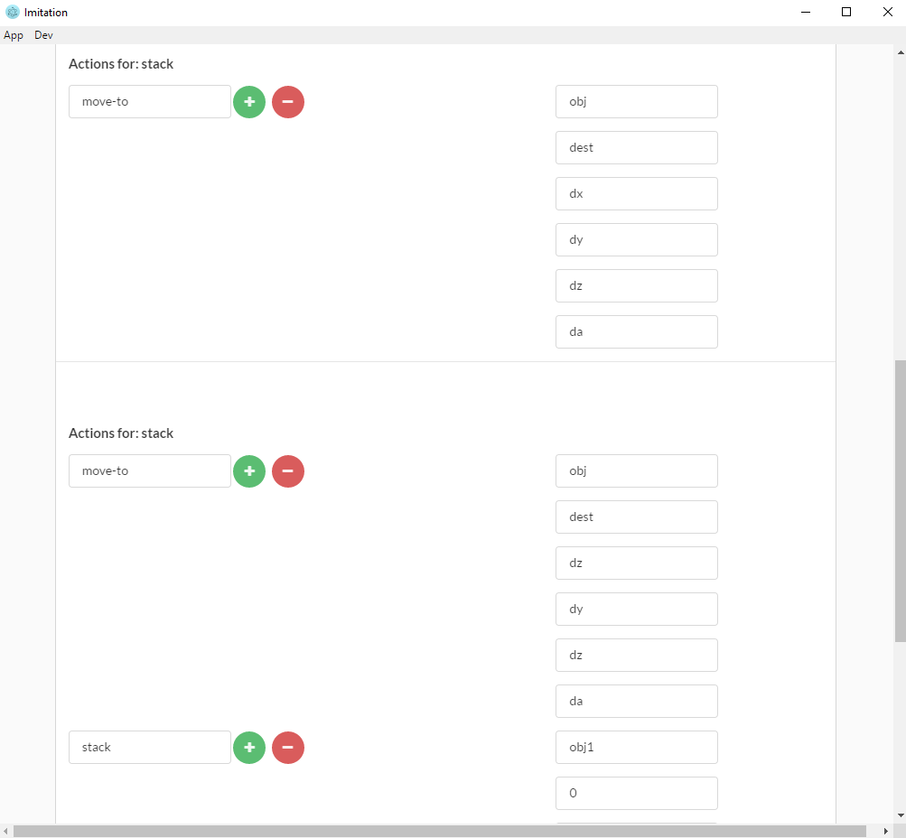

* 1. Define Causal Parameters
     1. First Click on Toggle Custom Parameters and add:
        + CONT1
        + CONT2
     2. Click on Add Parameters

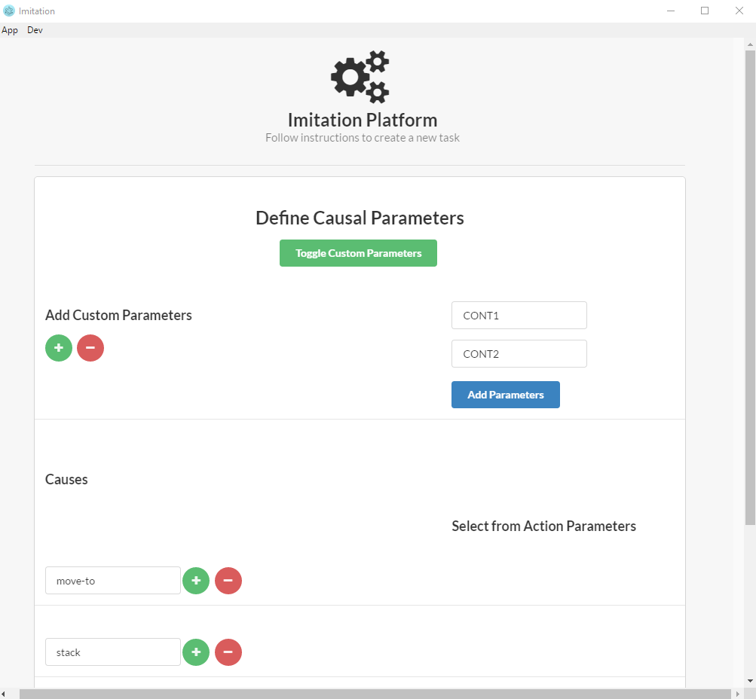

* + 1. Now define Causal Parameters – Select drop down options for:
       - Move-to
         1. Obj
         2. Dest
         3. Dx
         4. Dy
         5. Dz
         6. Da
       - Stack
         1. Dest
         2. Dx
         3. Dy
         4. Dz
         5. Da
         6. Obj
       - Stack
         1. Dest
         2. Dx
         3. Dy
         4. Dz
         5. Da
         6. Obj
       - Stack
         1. Dest
         2. Dx
         3. Dy
         4. Dz
         5. Da
         6. Obj1
         7. Obj2
         8. Obj3
         9. CONT3
       - Stack-all
         1. Dx
         2. Dy
         3. Dz
         4. da

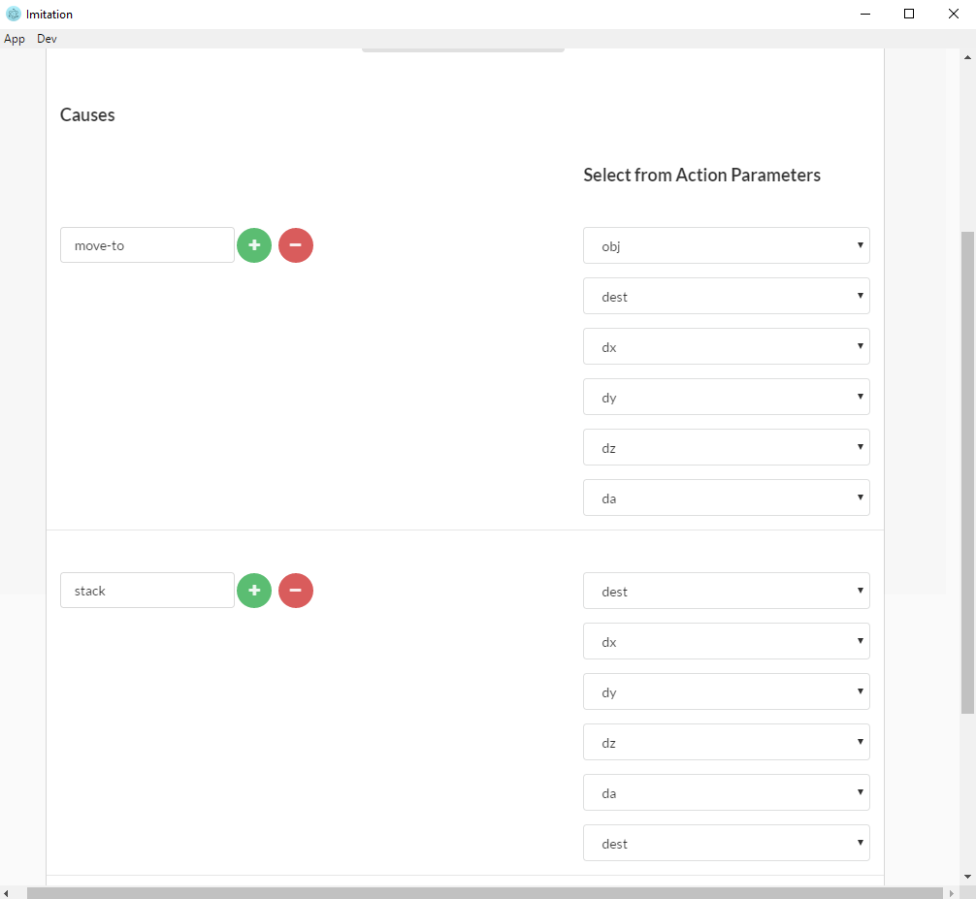

* 1. Once completed, you should be at the Build the text file page.
     1. Click Save, and choose where you would like the text file to be located

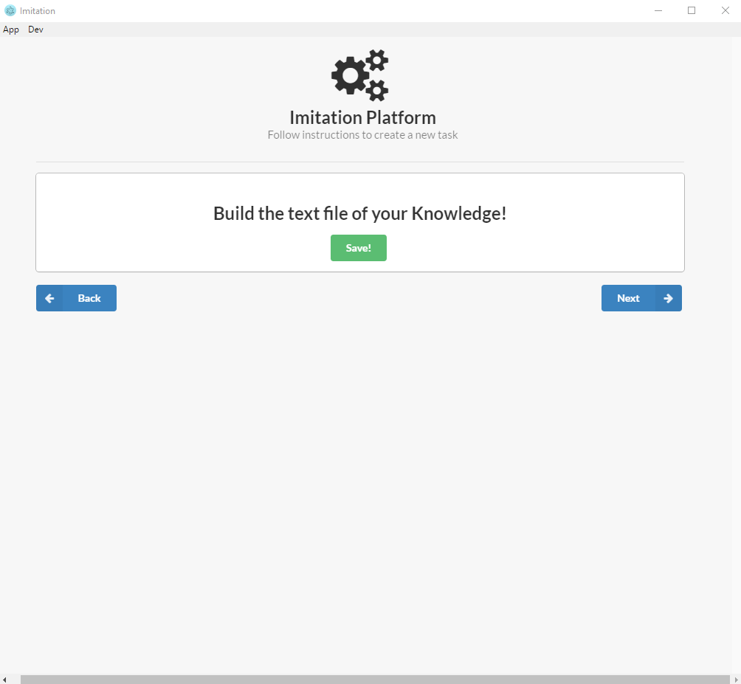

1. Once you click next you will be brought back to the Build your Knowledge Base Page.
   1. Click on Open File and select either the file just created

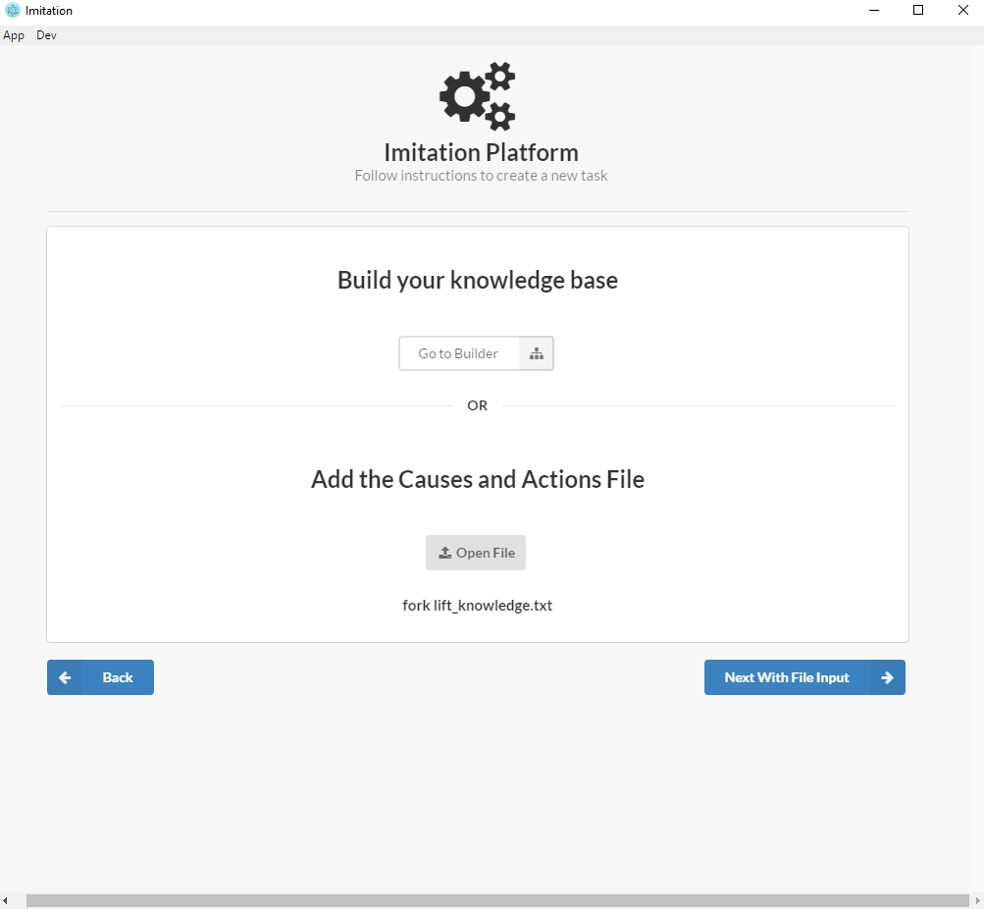

1. Final File Input,
   1. Upload the Initial State XML. The fork lift initial xml is located at

electron\Imitation\Forklift\Inital XMLs

* 1. Click Run!, and if everything is correct, that’s it!

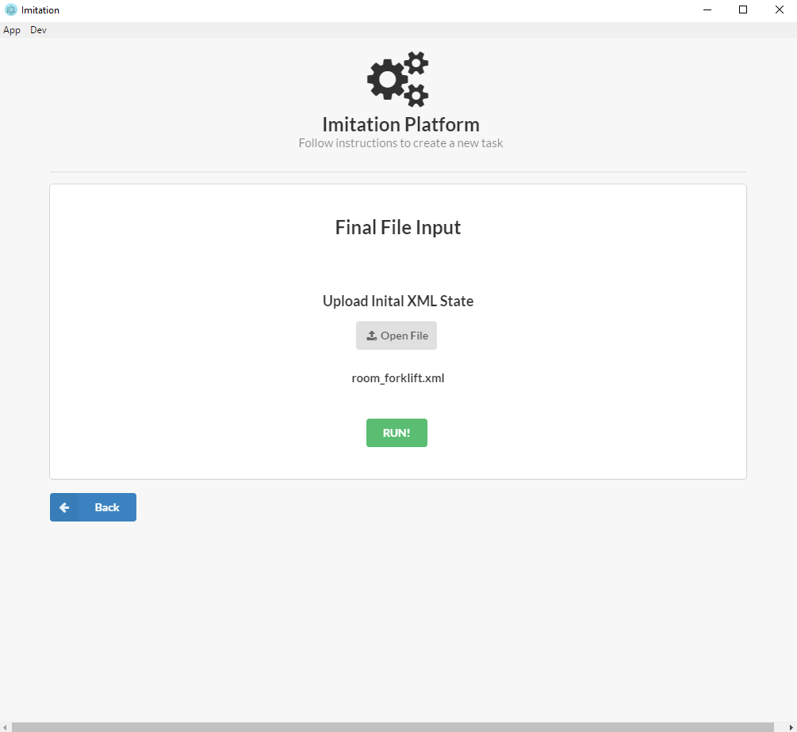

1. You will be brought to our final page where we designate the final file locations for your task!

